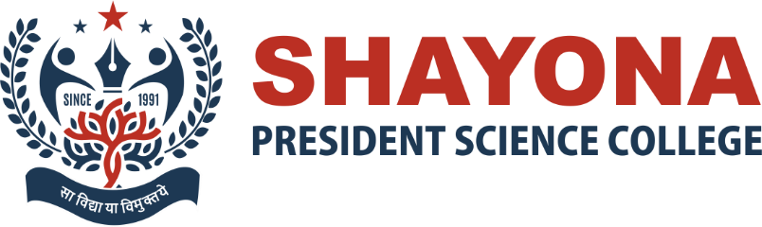
Summary report of 2nd Alumni Meet, 2021.
The 2nd Alumni meet was organized at President Science College on 30th September 2021. We welcomed all the alumni for responding to the invitation from college and being present for the alumni meet despite their busy schedule on working day. Dr. Shivangi Mathur then proceeded with presenting the college report highlighting the various milestones reached in the past years. Then, time had come to hear from the Alumni, a sharing session with the Alumni representing various batches since 2015 had been conducted to listen their past experiences and feedback. Vibrant performances by faculty members of the college made it very special and memorable.
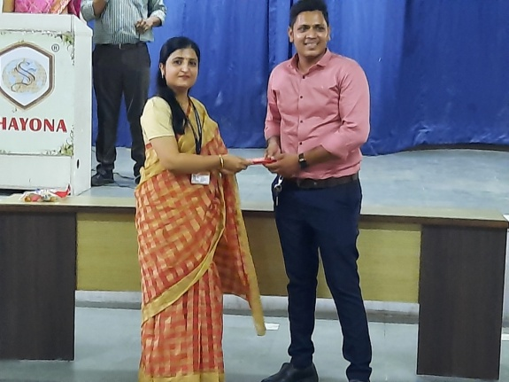 | 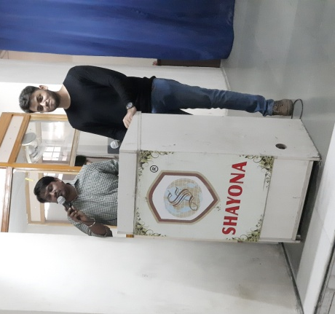
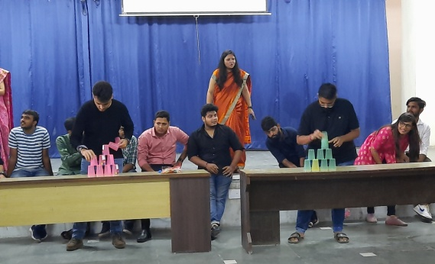
 | 